**A SUMMARY OF CLINICAL PHARMACOKINETICS - ALWYN PIDGEN**

**Pharmacokinetics** –is the study of changes in drug concentration over time as a drug moves through the body. It involves Absorption, Distribution, Metabolism and Excretion.

**Pharmacodynamics** – is the study of the effect a drug has on the body over time (efficacy, safety).

**ABSORPTION**

**Absorption** is the transfer of drug from the site of administration into the systemic circulation and is primarily affected by the **route** of administration.

Drugs given **intravenously** enter the systemic (vascular) circulation immediately. Absorption is not involved.

Drugs given **extravascularly** must undergo absorption in order to reach the systemic circulation. For locally acting drugs (e.g. topical products), systemic absorption is not required for efficacy but may occur and must be checked to rule out any potential toxicity.

In order to be absorbed a drug must first be in solution and then cross the membranes that divide the absorption site from the systemic circulation.

To be a successful candidate, a drug should have the right combination of **aqueous** and **lipid solubility** (Log P).

To ensure good absorption a solid oral dosage form should: -

* Disintegrate and dissolve into solution (dissolution)
* Transfer from the stomach into the small intestine (gastric emptying)
* Cross the gut wall membrane (lipophilicity and drug transport)
* Avoid high first pass metabolism by the liver

**Absolute Bioavailability (F)** is the fraction of drug (AUC) that is systemically absorbed following **extravascular** administration when compared to an i**ntravenous** dose. Bioavailability can be markedly affected by **'first-pass' metabolism**. This is the fraction of drug that is eliminated before it reaches the systemic circulation. The liver is the major organ involved. A high first-pass metabolism will result in a low bioavailability.

**Relative bioavailability** is the relative amount of drug from one (non iv) formulation that reaches the systemic circulation when compared to another (non-IV) formulation (e.g. tablet v oral solution). It is commonly used when an intravenous formulation does not exist or cannot be made.

Two medicinal products are classed as **Bioequivalent** if they are pharmaceutical equivalents and there is no statistically significant difference in the rate and extent of absorption of the active ingredient (see FDA/EMA guidelines).

**Bioequivalence** is accepted as a surrogate marker for clinical efficacy and safety providing that the formulation conforms to high quality standards in terms of its method of manufacture and the purity of its final pharmaceutical form.

Note: - These studies apply to small molecule drugs only – not biologicals (or Biotechnology) drugs.

Oral absorption may also be affected by co-administration with **food** and this must be studied as it may impact a drug’s regulatory label. Food can slow dissolution, delay gastric emptying and alter the pH of the stomach contents.

The maximum plasma concentration **(Cmax)** is reached when the **rate of absorption equals the rate of disposition** (distribution + elimination). It is dependent upon the dose, formulation, frequency of sampling times, solubility, dissolution, and first pass effect.

**P-glycoprotein** (P-gp) is an efflux pump that can actively transport drugs out of a cell. It can impact absorption, distribution, metabolism and excretion (e.g. digoxin, steroids, protease inhibitors). Drugs that induce P-glycoprotein (e.g. rifampicin) may reduce the bioavailability of any co-administered drugs. Drugs that inhibit P-glycoprotein (e.g. verapamil) may increase the bioavailability of any affected co-administered drugs.

**DISTRIBUTION**

**Distribution** begins the moment a drug enters the bloodstream. It is the reversible transfer of a drug between the plasma and various organs and tissues within the body. Its aim is to transport drugs to the receptor sites.

Drugs are not uniformly distributed throughout the body due to: -

**1. Blood flow**. Well-perfused tissues (e.g. liver, lung, heart) take up drugs much more rapidly and completely than poorly perfused tissues (e.g. fat, muscle, skin).

**2. Permeability**. Lipid-soluble drugs penetrate cell membranes faster than water-soluble drugs. High molecular weight drugs penetrate slowly.

**3. Protein binding**. Many drugs bind to plasma proteins (e.g. albumin). This can become clinically important if binding is > 95%. Only the unbound drug can penetrate receptor sites and is responsible for efficacy/toxicity

**4. Tissue binding**. Only unbound drug can enter and leave tissue sites. Extensive binding to tissues can delay the release of drug back into the plasma and prolong elimination.

**Volume of distribution (V)** is a theoretical concept that indicates how extensively a drug is distributed throughout the rest of the body when compared to the plasma. It is defined as the ratio of the amount of drug in the body (following an intravenous Dose) to the concentration of drug in plasma.

Volume = Amount of Drug in the body = Dose

Plasma Drug Concentration Conc’n

For a 70kg human the volume of total body water is 42L and the plasma volume is 3L.

In general, **small molecule drugs** that are **not extensively bound to plasma proteins,** will distribute to all tissues in the body, including fatty tissue - leaving very little drug within the plasma. Hence, the Volume of Distribution will be high and much greater than total body water. For example digoxin V=500L.

**Small molecule drugs t**hat **are extensively plasma protein bound** will remain for longer within the vascular circulation. Hence the plasma concentration will be high and the Volume of distribution will be low. For example, warfarin is 97% plasma protein bound and V=10L.

**Large molecule drugs** (e.g. monoclonal antibody drugs) are distributed to peripheral tissues mainly by paracellular/ transcellular movement following parenteral injections.

**Multi-drug therapy** can lead to competition for binding sites. Any displacement of a drug from a binding site could result in transient increases in unbound drug concentrations and possible toxicity.

Large molecule drugs do not readily cross the **blood brain barrier** nor do hydrophilic molecules. Lipid soluble molecules such as Thiopental and other barbiturate drugs rapidly cross into the brain. Active efflux transport (via P-gp) also regulates drug delivery to the brain.

**ELIMINATION**

All drugs are eventually eliminated from the body. This can occur via: -

* Metabolism
* Renal excretion
* Biliary excretion
* Pulmonary excretion (volatile anaesthetics only)
* Sweat, Breast milk, Saliva.

The potential for excretion of drug from saliva, sweat and breast milk is generally small. However, any drugs excreted via breast milk may cause toxicity to a breastfed infant.

**METABOLISM**

**Metabolism** is the enzymatic conversion of one chemical compound (the parent drug) into another (related) compound. Most drug metabolism occurs in the liver, although the gut wall, lungs and blood plasma may be involved. The main enzymes involved in drug metabolism belong to the cytochrome P450 group.

Water-soluble drugs are mostly excreted unchanged into urine via the kidneys. However, lipid-soluble drugs must first be metabolised into water-soluble compounds to enable renal excretion.

Drugs that are administered in an **inactive form** (e.g. codeine) and immediately converted by metabolism to a pharmacologically active form (e.g. morphine) are known as **pro-drugs**.

There are two blood supplies to the liver and the pathway taken will depend upon the **route** by which the drug is administered. The common hepatic artery is used following intramuscular, subcutaneous and sublingual/buccal administration. This has the advantage that drugs are distributed to the rest of the body before being metabolized by the liver (avoiding first-pass metabolism). However, any drugs given by the oral and rectal routes use the portal blood supply and will be metabolised by the liver before they enter the systemic circulation.

Patients with liver disease are likely to have different PK when compared to patients with normal liver function - requiring a dosage adjustment.

**RENAL EXCRETION**

The kidney is the most important organ for drug excretion.

Renal Excretion = Amount filtered – Amount reabsorbed + Amount secreted

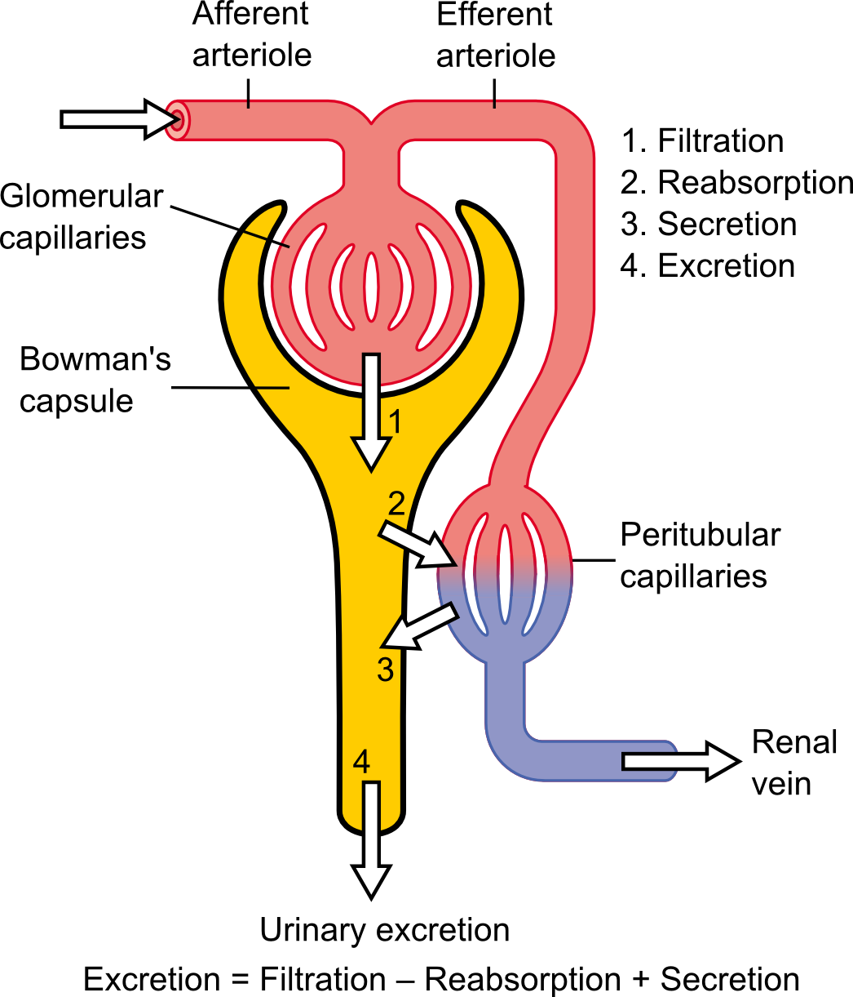

**Filtration** – Only unbound water-soluble drug (and metabolites) can be filtered by the glomerulus. The Glomerular Filtration Rate (GFR) is a valuable clinical indicator of renal function and is commonly estimated using serum creatinine. The GFR averages 110-130 ml/min in young healthy individuals and decreases gradually with age.

**Reabsorption** – Filtered drug can be reabsorbed back into the body (via the renal vein). It depends upon a drugs ability to cross membranes as well as the pH of tubular contents.

**Secretion** - Drugs that are not filtered by the glomerulus travel via the efferent arteriole and pass into the peritubular capillaries where they have another chance to be secreted into urine. For example, Penicillin is actively secreted from the blood into the nephron.

Drugs excreted mainly unchanged by the kidneys may require a dosage adjustment in Elderly patients and patients with Renal disease.

**BILIARY EXCRETION**

**Biliary Excretion** is the irreversible removal of drug from the body via the bile.

Drug and metabolite from the bile enters the GI tract via the gallbladder. Once in the GI tract it can be excreted from the body via the faeces.

Lipophilic drugs with a molecular weight between 300 and 500g/mol are most likely to undergo biliary excretion in humans. In a small number of cases drug secreted into the bile is reabsorbed back into the systemic circulation (e.g. carbamazepine) from the intestine (enterohepatic recirculation)

**CLEARANCE**

**Total drug clearance** (CLtotal) is the volume of plasma completely cleared of drug per unit of time (e.g. litres/h) and includes all major organs of elimination (primarily the liver and the kidneys)

**CLTotal = CLRenal + CLHepatic + CLOther**

Clearance reflects the efficiency of drug removal from the body.

**BIOLOGICAL HALF-LIFE**

The biological half-life (t1/2) is the time taken for the plasma concentration of a drug to fall by half. 95% of drug will have cleared from the plasma after 4.5 half-lives and 99% after 7 half-lives. This is important when assessing the washout period for crossover studies.

The half-life of a drug depends upon its Clearance and Volume of Distribution

t1/2 = 0.693 * V

CL

Drugs with long half-lives do not always have low Clearances. For example, Digoxin has a half-life of 1 day – but this is due mainly to V since drug is concentrated in the tissues and released only slowly back into plasma.

**LINEAR KINETICS**

To be able to select the right dose and make effective dosage adjustments - it is very important to understand how drug concentrations change with Dose and Time (duration). An early assessment of drug linearity can be obtained from the First in Human study.

Drugs are considered to be linear when: -

* Cmax, AUC and Ae increase proportionately to increases in dose (e.g. if the dose is doubled then Cmax and AUC should also double).
* The parameters of tmax, half-life, F, V and CLtotal remain unchanged after increases in dose.

Drugs are also considered to have linear kinetics if steady state concentrations remain constant when the same dose of a drug is given over a long period of time. This is particularly important for late stage clinical trials.

**METABOLIC SATURATION**

The therapeutic doses of some drugs (e.g. phenytoin) can lead to saturation of the metabolic enzymes in the liver and hence non-linear kinetics.



As drug enters the plasma, liver enzymes are activated and the rate of drug elimination increases in direct proportion to its plasma drug concentration. This is known as **linear kinetics** and applies to the majority of drugs. As the dose is increased, plasma drug concentrations also increase until a ‘**saturation point**’ is reached where the liver enzymes are working at maximum capacity. Beyond this point, any further increases in dose (and hence plasma drug concentrations) will not be matched by increases in the rate of drug elimination. This will result in a build-up of parent drug in the body and cause potential toxicity. This outcome is known as **non-linear kinetics.**

**ENZYME INDUCTION AND INHIBITION**

**Enzyme Induction** of one drug can result from its co-administration with another drug - causing an increase in liver enzyme activity over time. This can lead to unexpectedly lower plasma drug concentrations of the affected drug. For example, phenobarbitone induces its own metabolism as well as the metabolism of both phenytoin and warfarin.

**Enzyme inhibition** of one drug can result from its co-administration with another drug - causing a decrease in liver enzyme activity over time. This can lead to unexpectedly higher plasma drug concentrations of the affected drug. For example, warfarin inhibits the metabolism of tolbutamide leading to its non-linear accumulation upon multiple dosing requiring a dosage adjustment.

**MULTIPLE DOSING**

The aims of repeated drug administration to a patient are to ensure that concentrations quickly reach the therapeutic window and remain there for the duration of the treatment. Drugs with a narrow therapeutic window need close monitoring.

* Accumulation (build-up) occurs if drug from the previous dose is still present in the body when the next dose is administered.
* Steady state occurs when the rate of drug administered is equal to the rate of drug eliminated over the same time (i.e. the dosing interval).
* Actual steady-state drug concentrations depend upon the dose, dosing interval and half-life.
* At steady state, drug concentrations will fluctuate between a maximum and minimum value.
* The time to reach steady state is controlled solely by the elimination half-life of the drug.
* In practice, 97-99% of steady-state is reached within 5-7 half-lives

**TRADITIONAL V BIOTECHNOLOGY DRUGS**

|  |  |
| --- | --- |
| **Traditional drugs** | **Biotechnology drugs** |
| Chemical basis | Living Organisms |
| Small molecule | Large molecule |
| Oral dosing | Parenteral dosing |
| Variable PK | Predictable PK |
| Bioequivalence | Biosimilarity |

**POPULATION PHARMACOKINETICS**

Unlike classical early clinical studies where a drug’s PK is studied in healthy volunteers, the population approach to pharmacokinetics focuses only on patients who are receiving clinically relevant doses of a drug. The big advantage of Population PK is that it requires only a few blood samples to be taken from each patient to enable a population PK profile to be obtained. This can be particularly useful when investigating subgroups of the population that are difficult to study, such as infants, young children and the very elderly.

The overall concentration versus time data obtained from the target patient population is first modelled and key pharmacokinetic parameters such as Clearance (CL), Volume of Distribution (V) and Half-life (t1/2) are obtained. Variability such as Inter-individual, Intra-individual and Inter-Occasion are also estimated.

Certain characteristics of the patient population such as age, body weight, ethnicity, gender, co-medication and disease states, are known to influence the pharmacokinetics of some drugs. The Population PK model can be used to determine which (if any) of these characteristics are significant and hence require to be taken into account when making key recommendations (e.g. dosage adjustments)

**POPULATION PHARMACOKINETICS & PHARMACODYNAMICS (PK/PD)**

In Population PK/PD we measure a Pharmacodynamic (PD) endpoint (which can be Safety or Efficacy or both) at the same time as obtaining PK blood samples from each patient. This offers the opportunity to determine if there is any definable relationship between Concentration and Response in the target patient population. As with Population PK, only a few blood samples are taken from each patient.

Direct PK/PD models are used in cases where there is an instantaneous equilibrium (i.e. no time delay) between the appearance of the drug in plasma and the resultant PD response.

Indirect PK/PD models are used when there is a noticeable delay between the appearance of the drug in plasma and the resultant PD response. To establish this, plot the plasma concentration v PD effect data (ordered by time). If the resulting plot shows 2 different effect values at the same concentration (hysteresis curve) and a delay in the onset of effect.

As with Population PK, certain characteristics of the patient population (e.g. age, body weight, ethnicity, gender, co-medication and disease states, can alter the PK/PD relationship and must be taken into account when making key recommendations (e.g. dosage adjustments).

Alwyn Pidgen – July 2019